We don’t need more “Grabens” in Switzerland
Gian-Andrea Monsch, Karin Nisple, Stephanie Steinmetz
FORS, December 2020
At the beginning of December, the Zurich University of Applied Science proclaimed the word “Coronagraben” as the word of the year 2020 in the French speaking part of Switzerland. They state that “we have all lived a different reality according to our linguistic region.” In fact, infections with Covid-19 as well as political measures to fight against the spread of the virus varied a lot between German and Latin cantons. But do we live in different realities and is such a distinction a useful one? By looking at the population’s compliance with sanitary measures and the major population concerns since Covid-19 outbreak, we argue that it is not. We use data from the first wave of the MOSAiCH survey 2020 conducted before the semi confinement and from two waves of the FORS Covid-19 MOSAiCH survey fielded in spring and autumn 2020 (see box below/on the left/on the right).
Overall, a majority of the Swiss population is willing to comply with different measures to fight the Corona pandemic: 76% are willing to wear a mask, 6 out of 10 agree to install the SwissCovid application, and still more than half of the population are ready to get vaccinated. While this might indicate a compliance with those measures, an important part of the population was still critical against these measures in October 2020. Concerning the “Coronagraben” thesis, there are indeed some differences between the language regions (see Figure 1). While Latin cantons (82%) are more willing to wear a mask than German ones (74%), respondents from German speaking cantons are slightly more willing to install the SwissCovid tracing app (66% to 60% in the French and Italian speaking regions). In contrast, we find no difference for willingness to get vaccinated against Covid-19.
Figure 1: Compliance with Covid-19 measures (in %)
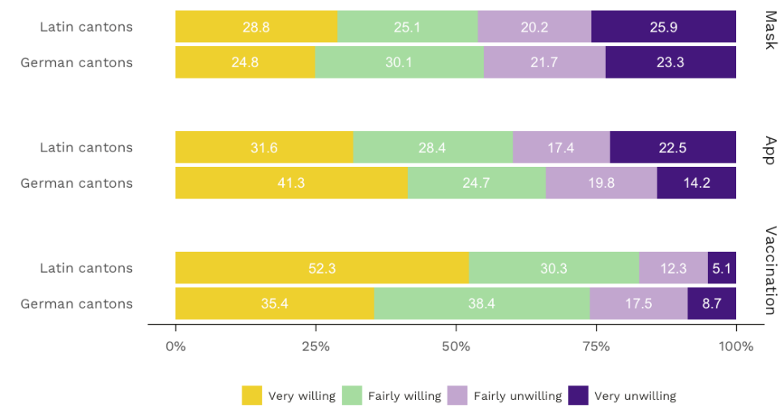
As much as we might conclude from this result that the linguistic regions live indeed in different realities, we also could argue that compliance with measures is a question of political couleur, job situation, gender, or age. The narrative could be one of the following: Respondents that feel close to right-wing parties are less willing to wear a mask (70%) than those who identify with left-wing parties (79%). Or, people above 65 (82%) are more willing to wear a mask than younger generations (31-64: 74%; 18-30: 77%). Similar narratives can be advanced for vaccination: We find that women (44%) are way more hesitant than men (64%), and that employers (43%) are more skeptical than employees (53%) and unemployed (59%). We could extend this list with examples for the SwissCovid app. The point is that language region discriminates neither in a stronger nor in a more homogeneous way than other factors we might think of.
A similar argument can be made concerning the dynamics of the most important problems for the Swiss population. During 2020, we asked the respondents at three different points in time what they consider the top two problems Switzerland is currently facing: Once we asked shortly before the semi-lockdown in spring, once during the state of emergency, and once shortly before the second wave of the virus in October. In this short time span, we saw a spectacular drop for environmental concerns from 55% to 37%. Meanwhile, economic ones had a sharp increase and went from 19% to 46% replacing thus environment as the second most important issue behind health care. Other issues remained remarkably stable and moved little in comparison to this trend (see Figure 2 below). Another item confirms that economy has become one of the major concerns over the year. We asked respondents whether they agreed with the following statement: “Rapid economic recovery is more important than protecting coronavirus risk groups.” In October and thus still before measures were taken to fight the second Covid wave, an astonishing 21% (strongly) agreed with this statement, 37% were indifferent, while 42% (strongly) disagreed.
Figure 2: Evolution of problems in Switzerland (in %)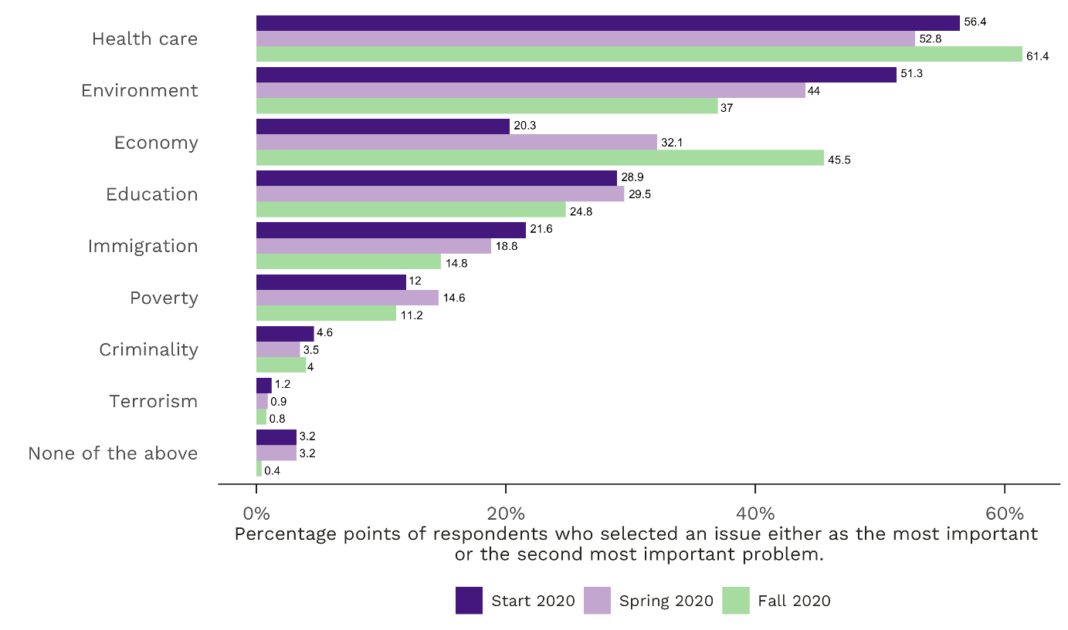
Once again, linguistic regions could be advanced as an argument to explain why the economy outruns the environment as the most pressing issue in Switzerland. Indeed, economic concerns are more prevalent in Latin cantons compared to the ones of fellow citizens on the other side of the Sarine (wave 1: 26% L-CH to 18% D-CH; wave 2: 42% to 28%; wave 3: 54% to 42%). Are thus the residents in the Latin cantons the main drivers of this turnaround? Probably not. If we look again at variations across different groups, we find no differences for job situation, gender, or age. However, respondents close to left-wing parties (65% in MOSAiCH; 57% in COVID-19 wave 1; 56% in COVID-19 wave 2) are more concerned by the environment than those close to right-wing parties (25% in MOSAiCH; 20% in in COVID-19 wave 1; 13% in COVID-19 wave 2). In parallel, the latter cite more often the economy (20%; 39 %; 46%) than the former (17%; 23%; 34%). Still, we cannot explain the general trend in Figure 2 through such group comparison as they evolve in the same direction.
The conclusion is thus another one: The Corona pandemic has left its imprint all over Switzerland. Certainly not with the same force for everyone but in a similar way. Thus, we need perhaps more bridges than grabens. In this regard, given that older adults (65+) are the most willing group to get vaccinated (70% versus 50% for 31-64 and 47 for 18-30), and the younger ones (18-30) are the least inclined to sacrifice risk groups for rapid economic recovery (14% compared to 22% for the 31-64 and 20% for 65+), our results might rather be interpreted as intergenerational solidarity.

FORS Covid-19 MOSAiCH Survey
In order to better understand the impact of Covid-19 on society in Switzerland, a three-wave online panel survey with questions on the coronavirus pandemic and the measures to control the spread of the virus was added to the annual social survey MOSAiCH (https://forscenter.ch/mosaich/).The focus of this Covid-19 survey is on questions about well-being, work, work-life balance, and politics. The first wave was fielded from end of April to mid-June 2020.The online questionnaire was answered by 2421 people living in private households in Switzerland and aged 18 or above. The second wave was surveyed during the month of October 2020 and answered by 1270 respondents. The results were statistically weighted to achieve better representativeness for the Swiss population. The respondents will be invited to a third wave in spring 2021, which will allow to measure the impact of Covid-19 in the longer term.

Corresponding author: gianandrea.monsch@fors.unil.ch. The fact that the first author lives in Geneva but has his origins in the German speaking part of Switzerland is in no way related to the conclusions in this article.
The literal translation of graben is rift. However, here it is used to indicate cultural or political divisions. In imitation of the term “Röstigraben” indicating the cultural divisions between the German and Latin part of Switzerland, “Coronagraben” underlines the disagreements about the adoption of sanitary measures as well as the strong differences in infection numbers between the regions.
We allow ourselves to combine Italian and French speaking cantons because they were more affected by Covid-19 than the German speaking cantons. We classified Geneva, Vaud, Neuchâtel, Fribourg, Valais, Jura, and Ticino as Latin cantons.
Respondents from Latin cantons also cite more the environment as an issue but only in the first wave of the survey (57% to 49%). In the following two waves, we find no more significant differences between the two regions for this issue.

